=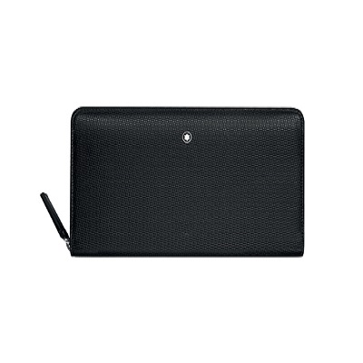

Montblanc : Wallet 8 Pockets with Zipped and Coin Purse UNICEF

PRODUCT DETAILS

**Brand: Montblanc**

**Collection: Meisterstück Selection**

**Gender: Woman**

**Categoria: Wallets**